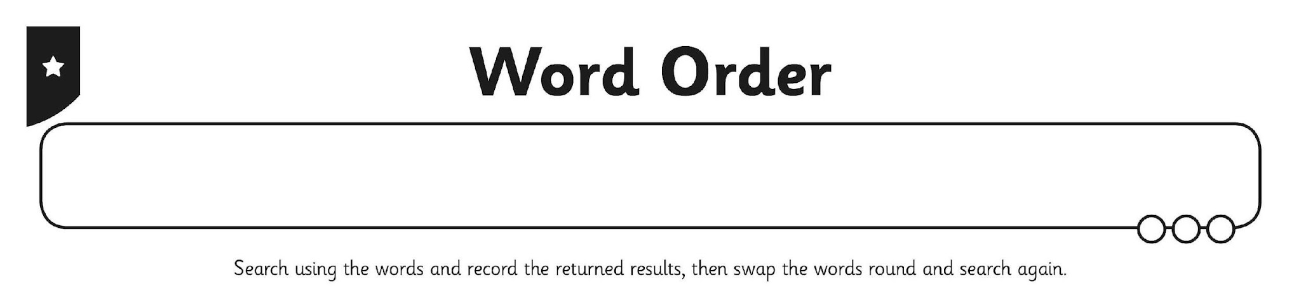
I can use different word orders when searching.

Insert 2-3 words which you will be searching for here: ______________/_______________/________________  Arrange them in 3 different ways/order | Insert 2-3 words which you will be searching for here: ______________/_______________/________________  Arrange them in 3 different ways/order
1. | 1.
2. | 2.
3. | 3.

